**ARYAMAN MISHRA**

**19BCE1027**

**LAB 1**

**1.Create topology with 2 switches,2 routers and 6 PC Devices.**

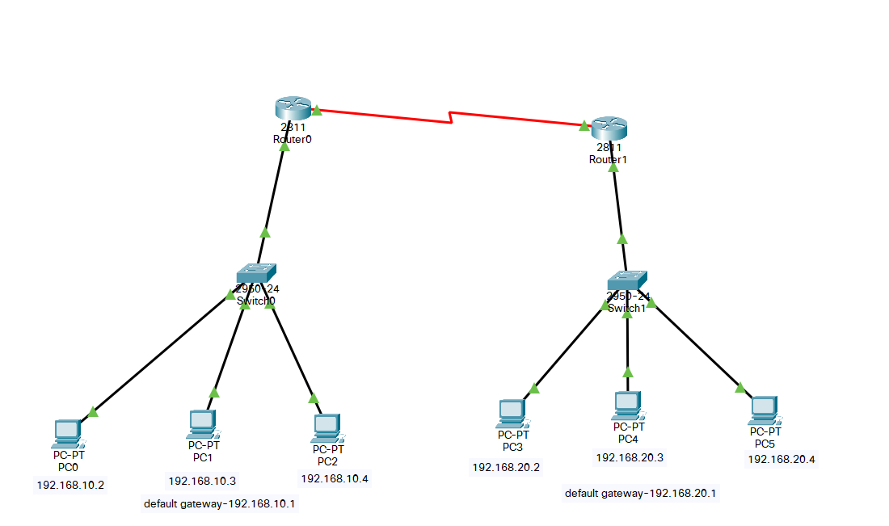

**2.Insert IPv4 Address in the config menu of the routers and turn them on.**

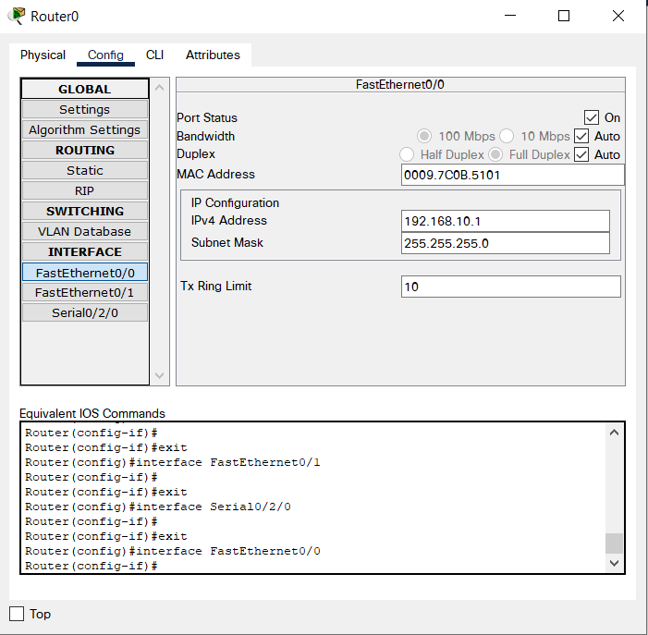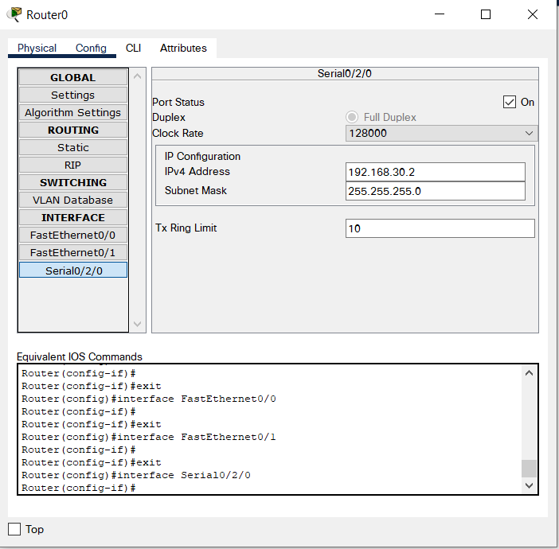

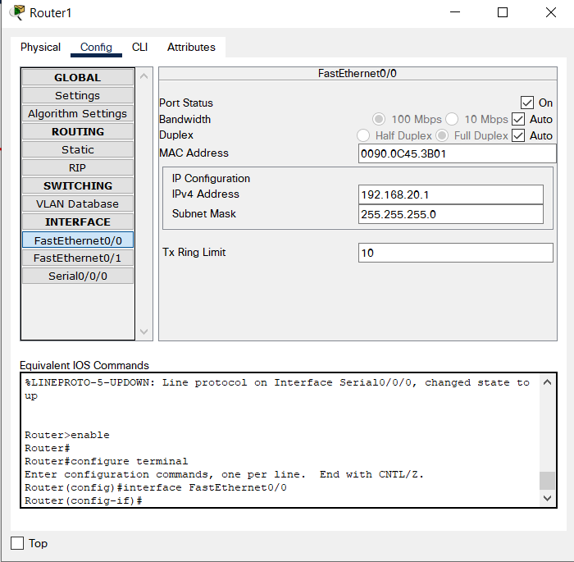

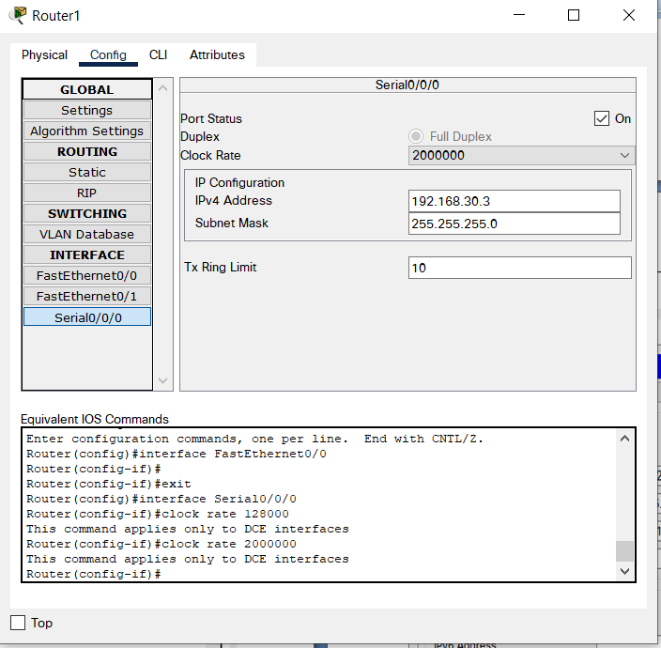

**3.Enter IPv4 Address and Default gateway in the config menus of the PCs and set their interfaces to static.**

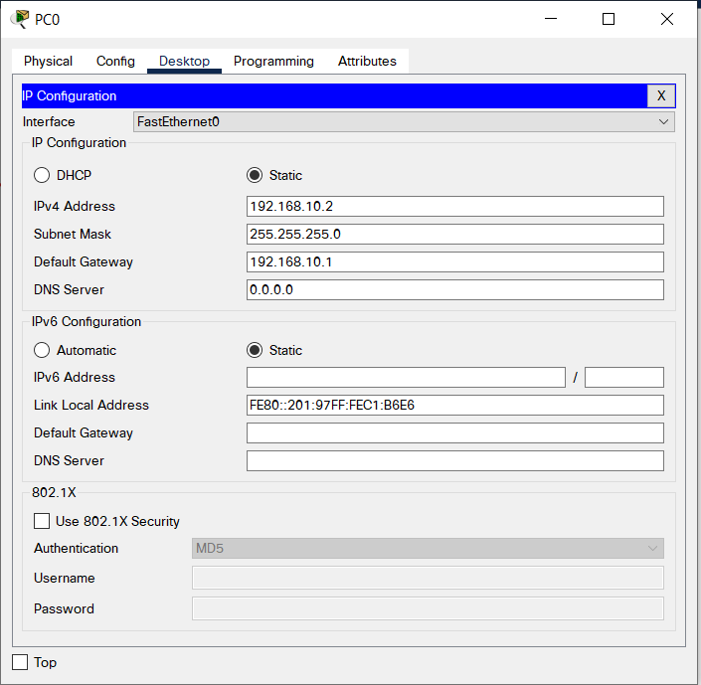

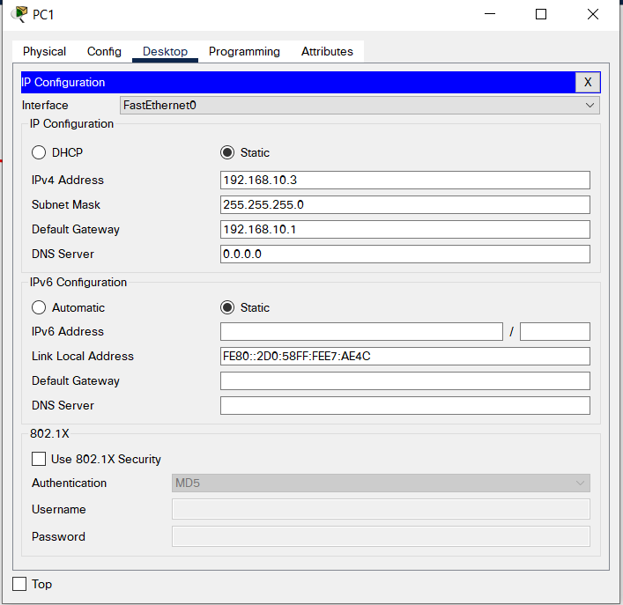

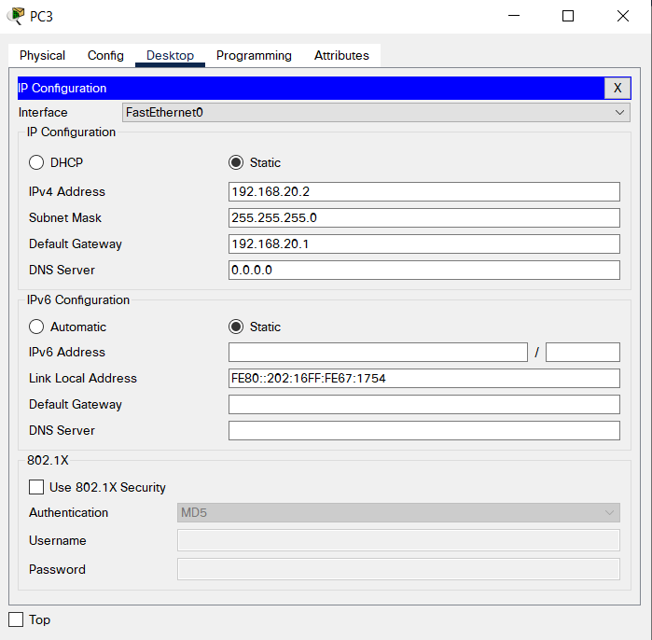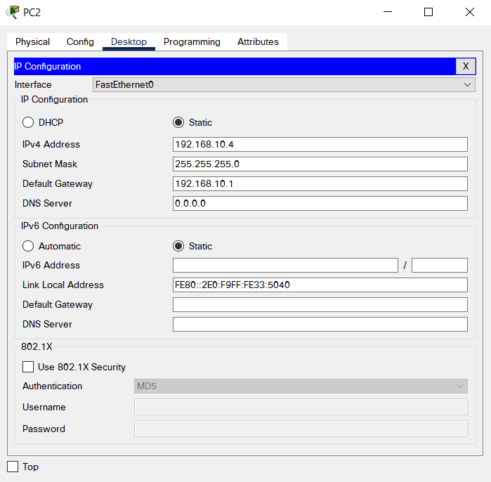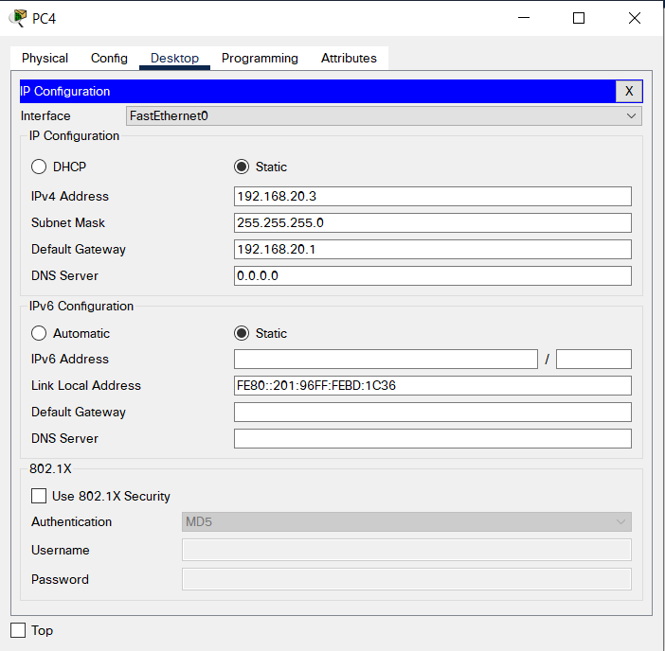

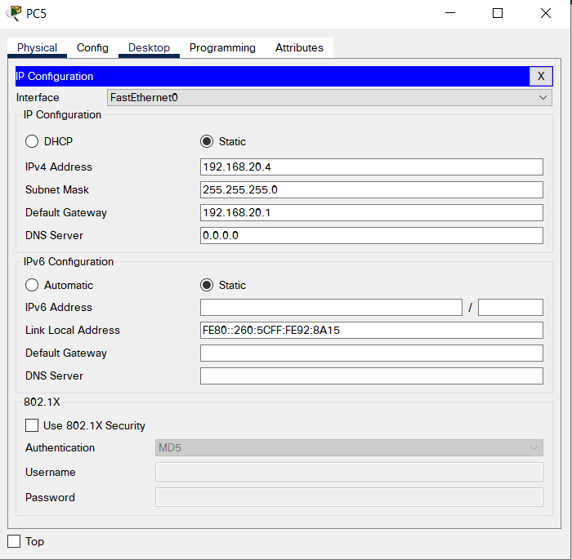

**4.Add WIC-IT Port to connect the routers,and turn them on.**

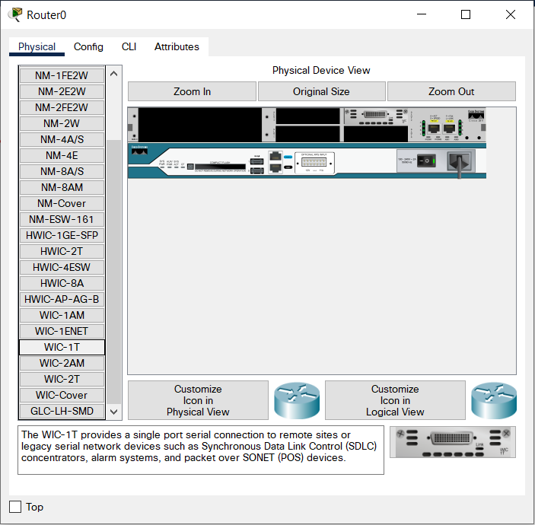

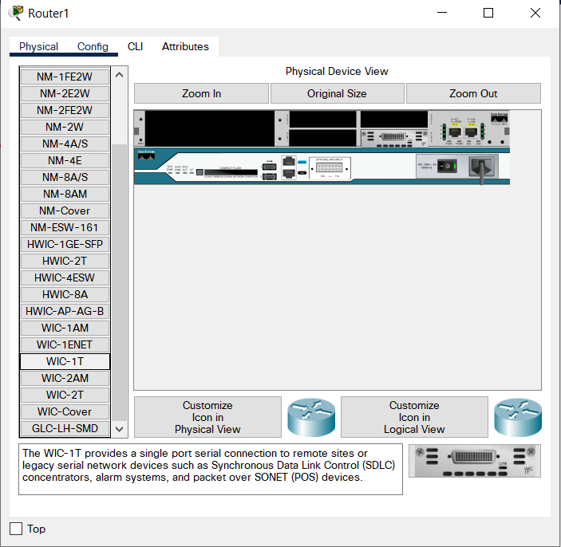

**5.Define IP Route and Serial Port in the CLI menu of the routers.**

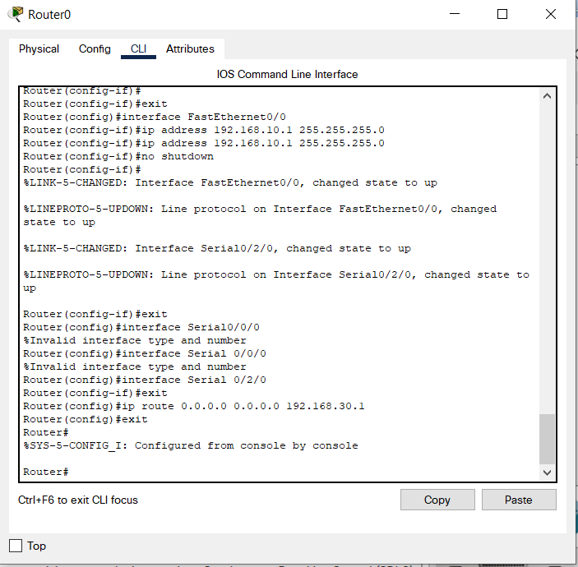

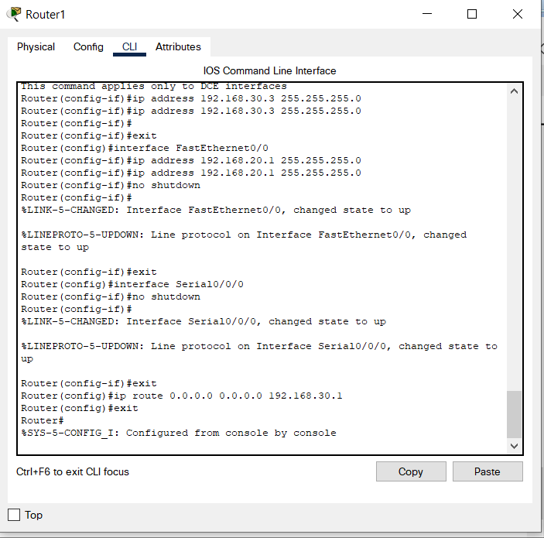

**6.Test proper connection of the PC devices using the simulation menu.**



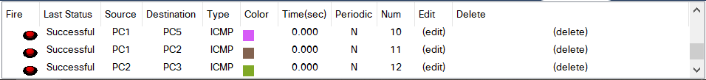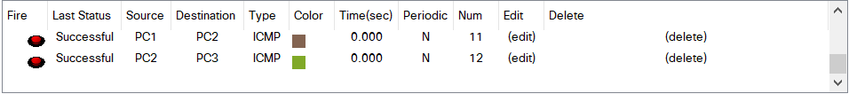

**CONCLUSION:**

**DESIGNED TOPOLOGY HAS BEEN EXECUTED SUCCESFULLY.**